REGNAcon! React Native Project Update

- Introduction
- This will be a continuation of the React page for “REGNAcon!”, the fictnional culture convention being held in Nashville, March 20-22nd, 2020. Its main features will be tabs for Guest information, events and times, ticket information, along with About and Contact information in a mobile format.
- User Interface Design/Examples
- The user interface will be based around a left side navigation drawer with options for different pages.

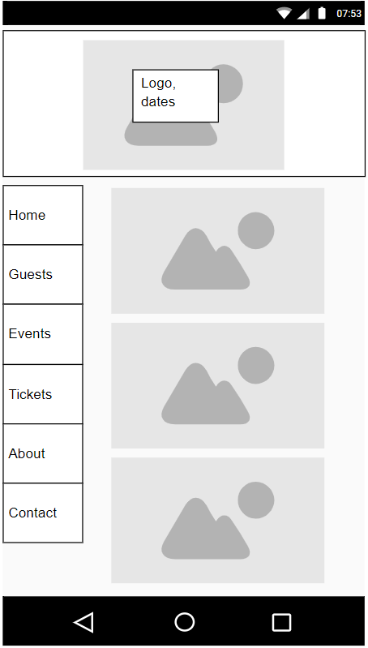
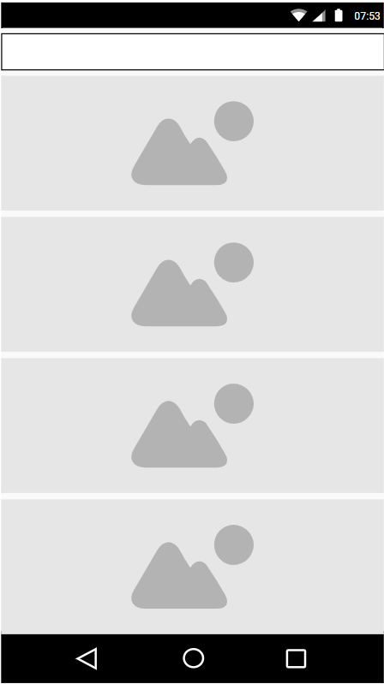

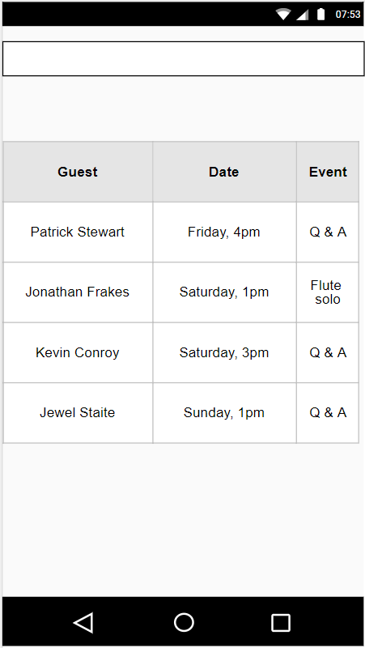
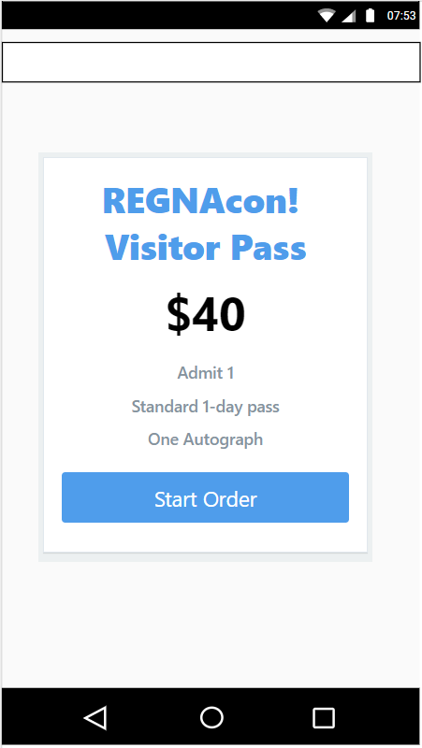
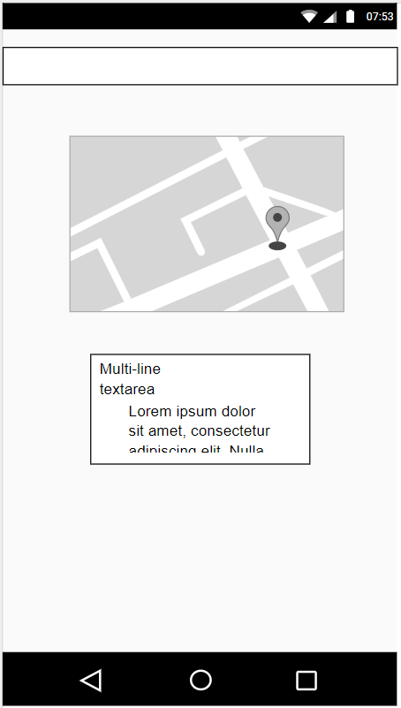
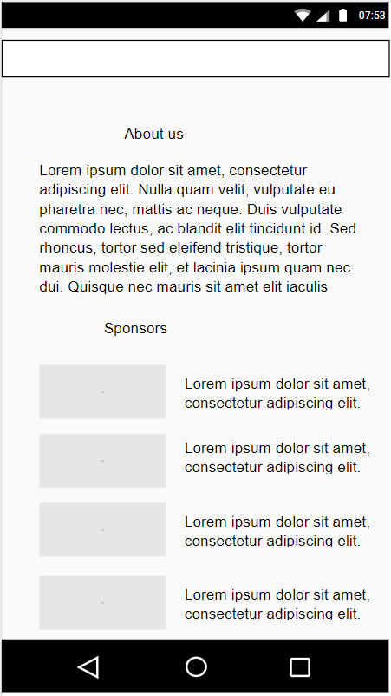

- Navigation Structure
- Each side drawer navigation option (Home, Guests, Events, Tickets, About, Contact) will take user to the appropriate window with the corresponding page. The Guest listings will expand into an additional page of Guest Information when each guest is selected.
- References
- Inspiration based on apps offered by other organizations providing similar experiences:
Grand Rapids Comic Con - https://play.google.com/store/apps/details?id=com.grandrapids.comiccon&hl=en_US
San Diego Comic Con - https://play.google.com/store/apps/details?id=com.elementalbits.comiccon&hl=en_US

